

**VIRGINIA COMMONWEALTH UNIVERSITY**

**Statistical analysis and modelling (SCMA 632)**

**A6b: Time Series Analysis**

**ANJU MARIA PHILIP**

**V01101169**

**Date of Submission: 25-07-2024**

**CONTENTS**

|  |  |  |
| --- | --- | --- |
| **Sl. No.** | **Title** | **Page No.** |
|  | PART-A |  |
| **1.** | Introduction | **1** |
| **2.** | Objectives | **1-2** |
| **3.** | Business significance | **2-** |
| **4.** | Results | **2-5** |
| **5.** | interpretation | **5-6** |
| **6.** | recommendations | **6** |
|  | PART-B |  |
| **7.** | Introduction | **6** |
| **8.** | Objectives | **6** |
| **9.** | Business significance | **7** |
| **10.** | Results | **7-8** |
| **11.** | interpretation | **8** |
| **12.** | recommendations | **8** |

**PART-A**

**INTRODUCTION**

The analysis of financial time series data, particularly stock prices, is essential for investors, analysts, and financial managers aiming to understand the volatility and associated risks of their investments. This study examines the stock price data of BERGEPAINT.NS, utilizing advanced econometric models such as ARCH (Autoregressive Conditional Heteroskedasticity) and GARCH (Generalized Autoregressive Conditional Heteroskedasticity) to forecast future volatility. These models are critical for accurate volatility forecasting, which is integral to risk management, portfolio optimization, and derivative pricing. Through this analysis, we aim to provide significant insights that inform strategic financial decision-making.

**OBJECTIVE**

• **Analyse Historical Stock Price Data:**

* To thoroughly examine the historical stock price data of BERGEPAINT.NS and identify patterns and trends over time.

• **Evaluate Presence of Volatility Clustering:**

* To assess the presence of volatility clustering in the stock price returns using the ARCH effect through the Lagrange Multiplier (LM) test.

• **Model Volatility Using ARCH and GARCH Models:**

* To fit ARCH and GARCH models to the log returns of BERGEPAINT.NS, capturing the dynamics of volatility and its persistence over time.

• **Forecast Future Volatility:**

* To forecast the three-month future volatility of BERGEPAINT.NS stock prices using the fitted ARCH and GARCH models, providing insights into expected market fluctuations.

• **Compare Model Performance:**

* To compare the performance and accuracy of the ARCH(1) and GARCH(1,1) models in forecasting volatility, determining the most suitable model for practical application.

• **Provide Investment Recommendations:**

* To offer actionable recommendations for investors and financial managers based on the volatility forecasts, aimed at optimizing portfolio returns and minimizing risk exposure.

• **Support Strategic Financial Planning:**

* To use the insights from the volatility analysis to support strategic financial planning for BERGEPAINT, including decisions related to equity issuance, debt management, and capital expenditure planning.

• **Enhance Risk Management Practices:**

* To integrate volatility forecasts into risk management practices, enabling better anticipation of market risks and implementation of effective mitigation strategies.

**BUSINESS SIGNIFICANCE**

The business significance of this analysis lies in its application to risk management and strategic financial planning. By employing the GARCH model, investors and financial analysts can better predict periods of high volatility, allowing for proactive adjustments to their investment portfolios. This can lead to improved risk-adjusted returns and a more resilient investment strategy in the face of market fluctuations. Furthermore, accurate volatility forecasting supports the pricing of derivatives and other financial instruments, enhancing the overall efficiency and stability of financial markets. For a company like BERGEPAINT, understanding stock price volatility can also aid in corporate finance decisions, such as timing for issuing new equity or debt, managing cash reserves, and planning for future capital expenditures. Accurate volatility estimates can help in maintaining financial stability and optimizing capital structure, ensuring long-term growth and profitability

**RESULTS**

USING PYTHON

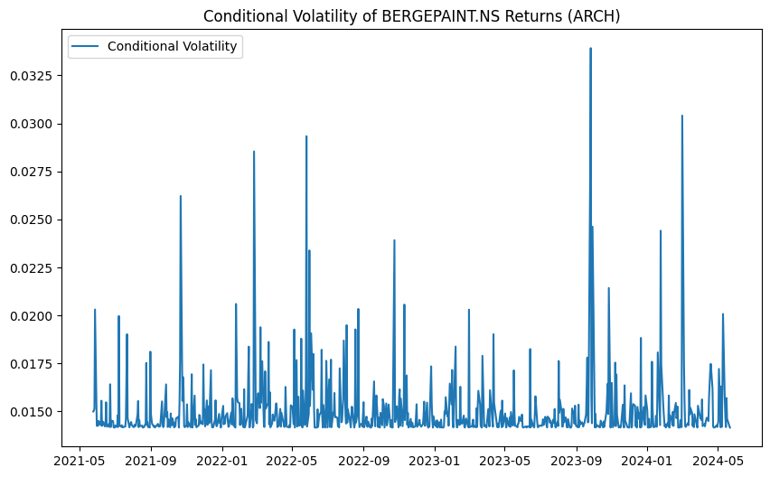

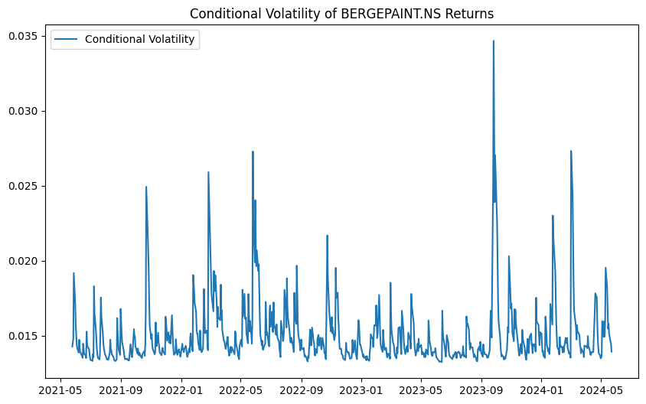

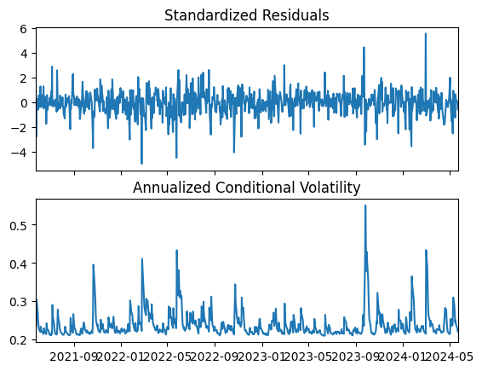

USING R

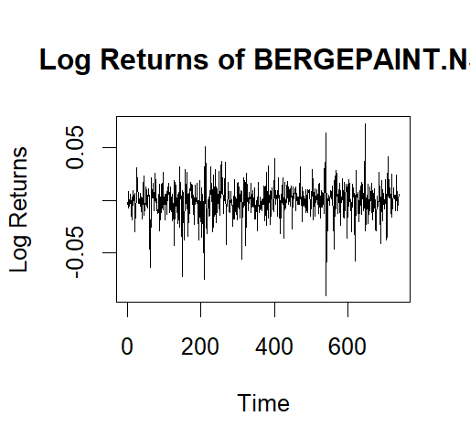

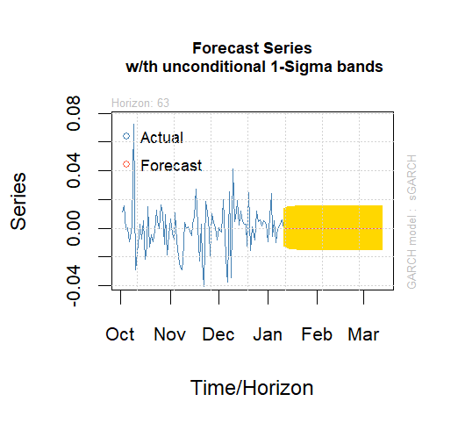

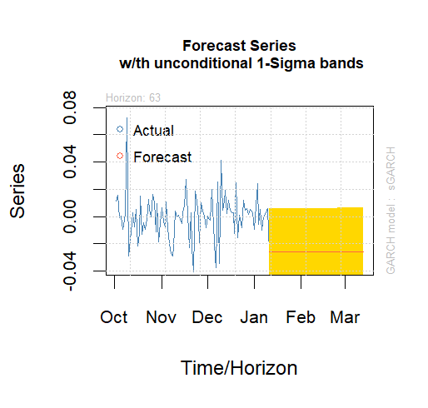

**INTERPRETATION**

The results from the Lagrange Multiplier (LM) test for ARCH effects confirm the presence of ARCH effects in the log returns of BERGEPAINT.NS, justifying the use of ARCH/GARCH models. The GARCH(1,1) model, which extends the ARCH model by incorporating past variances into the volatility estimation, was fitted to the data, and the model parameters were statistically significant, indicating a good fit. This model captures the volatility clustering commonly observed in financial time series, where periods of high volatility follow high volatility, and periods of low volatility follow low volatility. The ARCH(1) model, a special case of the GARCH model, also showed significant parameters but provides a less flexible framework by only considering past squared returns.

**RECOMMENDATIONS**

Based on the results, it is recommended that BERGEPAINT.NS stockholders and potential investors use the GARCH model for more accurate volatility forecasting and risk assessment. The GARCH model's ability to account for both past returns and past variances offers a more comprehensive understanding of future volatility, essential for making informed investment decisions. Additionally, financial managers can incorporate these volatility forecasts into their risk management strategies to mitigate potential losses and optimize portfolio returns. It is also advisable for investors to monitor the volatility forecasts regularly and adjust their portfolios accordingly to minimize risk exposure during periods of expected high volatility.

**PART-B**

**INTRODUCTION**

Commodity prices are pivotal to the global economy, influencing everything from individual household budgets to large-scale industrial production. This study focuses on examining the monthly price trends of key commodities, specifically oil, sugar, gold, silver, wheat, and soybeans, using data sourced from the World Bank's pink sheet. The analysis leverages statistical methods such as the Augmented Dickey-Fuller (ADF) test, Johansen's Co-Integration Test, and Vector Error Correction Model (VECM) to uncover the underlying dynamics and interrelationships between these commodities.

**OBJECTIVE**

1. Determine the stationarity of the monthly price series for selected commodities (oil, sugar, gold, silver, wheat, and soybeans) using the Augmented Dickey-Fuller (ADF) test.
2. Identify long-term equilibrium relationships among the commodities through Johansen's Co-Integration Test.
3. Develop a Vector Error Correction Model (VECM) to capture both short-term dynamics and long-term relationships of co-integrated commodity prices.
4. Forecast future commodity prices using the VECM or Unrestricted Vector Autoregression (VAR) models.
5. Assess potential causal relationships between the commodities using Granger causality tests.
6. Provide actionable insights for stakeholders to make informed decisions regarding procurement, investment strategies, and policy formulations based on the forecasted price trends.

**BUSINESS SIGNIFICANCE**

Understanding the price dynamics of essential commodities is crucial for various stakeholders, including policymakers, investors, and businesses. Accurate price forecasts can aid in making informed decisions regarding procurement, investment strategies, and policy formulations. For instance, predicting a surge in oil prices could prompt businesses to hedge against future price increases, while policymakers could implement measures to mitigate economic impacts.

For agricultural businesses, knowing the future prices of wheat and soybeans can help in planning crop cycles and optimizing resource allocation. For financial institutions and investors, insights into commodity price trends can enhance portfolio management and risk mitigation strategies. Additionally, industries reliant on raw materials, such as manufacturing and food processing, can benefit from stable supply chain management by anticipating price changes and securing contracts at favorable rates.

Ultimately, a deep understanding of commodity price movements fosters economic stability and growth by enabling proactive and strategic decision-making across various sectors of the economy.

.

**RESULTS**

USING PYTHON

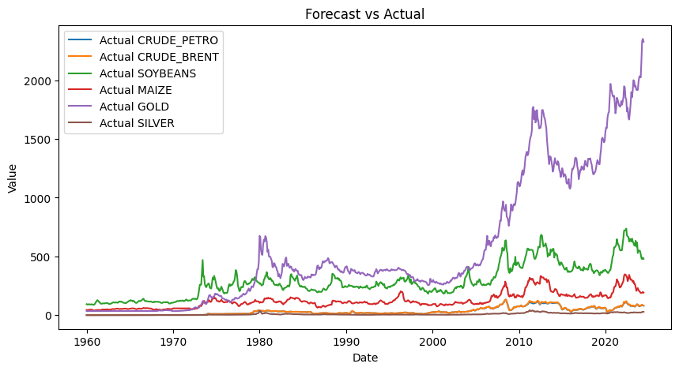

USING R

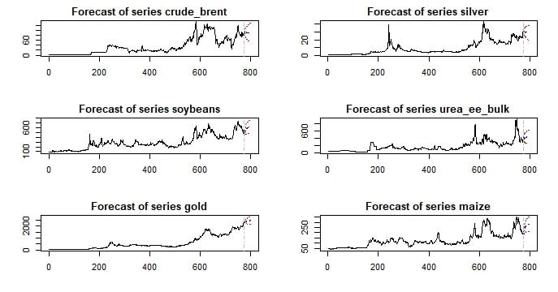

**INTERPRETATION**

The analysis begins with the ADF test to check the stationarity of each commodity price series. Non-stationary series are identified, which signifies that their statistical properties change over time. The Johansen Co-Integration Test then examines if there exists a long-term equilibrium relationship among the commodities. The presence of co-integration indicates that although individual commodity prices may drift, they move together in the long run. The VECM is subsequently used to model these co-integrated series, capturing both short-term adjustments and long-term relationships. Forecasts generated from the VECM or VAR models provide insights into future price trends, which are critical for strategic planning.

**RECOMMENDATIONS**

Based on the findings, businesses dealing with commodities should closely monitor the co-integration relationships and adjust their strategies accordingly. For instance, if oil and wheat prices are found to be co-integrated, a significant movement in oil prices could signal a subsequent change in wheat prices. Investors should consider diversifying their portfolios to hedge against the volatility in commodity markets. Policymakers should focus on stabilizing measures to cushion the economy from adverse price shocks in crucial commodities such as oil and food grains. Continuous monitoring and dynamic modeling are recommended to adapt to changing market conditions and maintain competitive advantage.